How to create a YouTube Channel by @SylviaDuckworth
UPDATED June 24, 2013 (New YouTube One Channel Layout)

1. How to change your profile photo
2. Adding channel art
3. Adding a Featured video (channel trailer) on your channel
4. Feature other channels on your channel
5. How to add create playlists (before adding videos to your channel)
6. How to add other peoples’ videos to your channel (in your playlists)
7. How to upload your own videos

Click here for official YouTube information and here for video tutorials or simply follow the steps below:

- go to www.youtube.com
- If you already have a gmail address, click on “Sign in”. If you don’t, click on “Create account” (top right-hand corner) and fill out boxes. Now go to www.youtube.com and sign in.

You might see this:

- If you do, skip the categories. Click on “Next”

- Click on your name, top right hand corner:
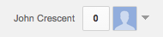
- You should see this:
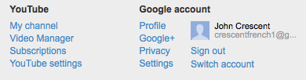

- Click on “My channel”
- You should see this:

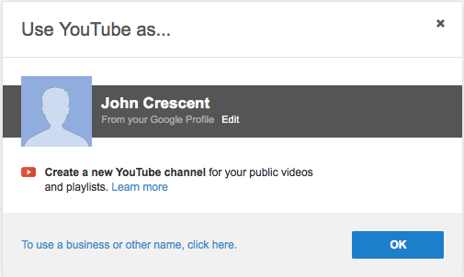

- If you want to change your YouTube channel name, click on “To use a business or other name, click here” *I strongly recommend that you do this, otherwise your channel’s URL will be a random number like: http://www.youtube.com/channel/UCQx5I9DZGCRRQDYYTeAqRsQ

- You should now see this:
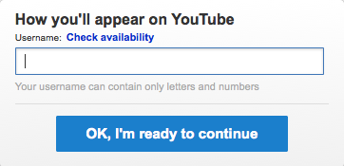

- When you are done, you should now see this:
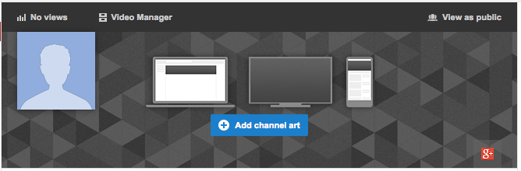

1. How to change your profile photo

- If you want to add a photo of yourself, click on the pencil icon on the head silhouette
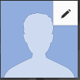
- You should see this:
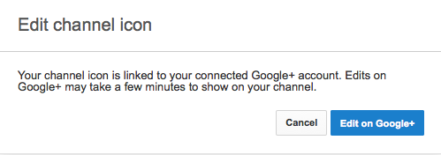

- Click on “Edit on Google+” to change your photo.

2. Adding channel art

- If you want to add channel art to your channel, click on
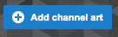

For now, it might be easier just to choose a photo from the gallery already set up in Youtube:
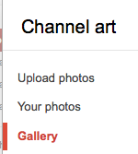

- However, if you want to use your own photograph, browse for an image on your computer, or go to Google Images and find a photo (save it on your desktop)
- Now click back on “Add channel art” button and browse to the photo. If you get this message:
You need to make the photo larger. Go to http://www.resizeimage.4u2ges.com/ and click on
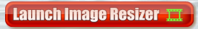
- Click on “Browse”, then “Upload image”
- On the top left hand corner, change the “Width” to 2048 pixels. The height will automatically change. Then click on “Resize/Process”
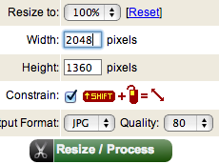
Then,
Put the re-sized image on your desktop and click on “Add channel art” button again.

- Regardless if you choose a photograph from their gallery, or one of your own, you will see this:
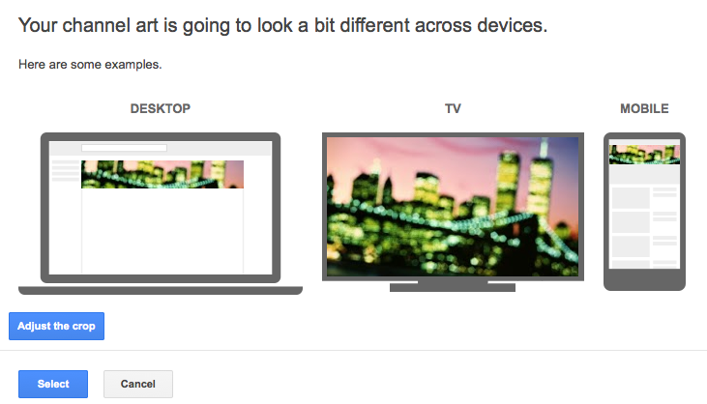

- Experiment with “Adjust the crop” button. You will notice that only a small portion of the photo will be seen on your channel (only the small rectangle in the middle of the photo will be seen).

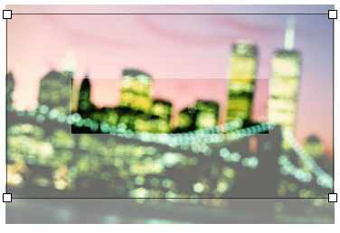

- Click “Select”
- If you want to change the crop after, or change the photo, click on the pencil icon on the top right hand corner of the image:
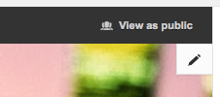

- Click on “View as public” to see how your channel looks to others. Click “Done” to return to editing your channel.

3. Adding a Featured video (channel trailer) on your channel

If you want to add a featured video (channel trailer) on your channel like on my channel:
http://www.youtube.com/user/sduckworth100
you need to upload a video first.

- Under your name, click on “Videos”, then, “+ Upload a video”
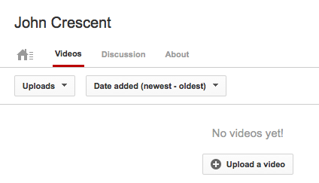

If you don’t have a video of your own to upload, just skip this part for now and go to the next section (#4), below.

- Now that you have a video uploaded, you can use it as your channel trailer. Click on the pencil icon just under your channel art.

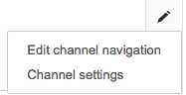

- Click on “Edit channel navigation

- Click on “Enable”
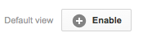
- Scroll to the bottom and click on “Save”
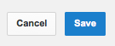
- Now you should see a “+ Channel trailer” button. Click on it. Click on your video, then click “Save”.
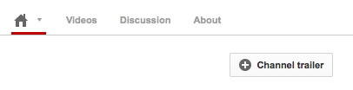

4. Feature other channels on your channel

- You can feature other channels that you like by clicking the “+ Add channels” button:
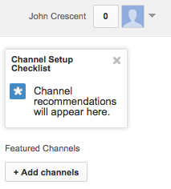

- Where is says “Enter channel URL”, add channels that you like, for example,

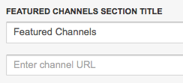
http://www.youtube.com/user/sduckworth100 is my channel. Cut and paste it in, then click on “+Add”, then “Done”. You should now see my channel under “Featured channels” of your channel.
- If you want to get rid of the “Popular Featured channels”, click on “Disable”:
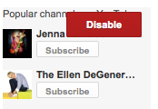

5. How to add create playlists (before adding videos to your channel)

- On the left hand side, click on “Playlists”:
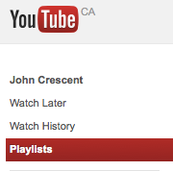

- In the middle of the page, click on “Create a playlist”:
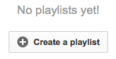
- On the right hand corner, click on “+ playlist” and name your playlist, then click on “Create playlist”. 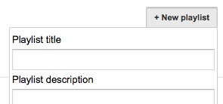
(You can skip the “Playlist description”)
- You might want to just start with creating a playlist for “French”, but have a look at my channel to see what playlists I have. http://www.youtube.com/user/sduckworth100

- If you want to add more playlists, click on your name on the top right hand corner, then click on “Video manager”:
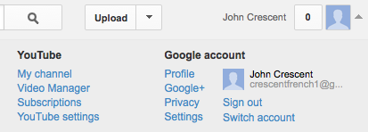

- On the left hand side, click on “Playlists”

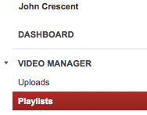
- then on the top right hand corner, click on “+ New playlist”
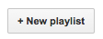
- Try adding a couple of more playlists like “Funny” or “Lessons”. Now when you click on your playlists, you should see this:

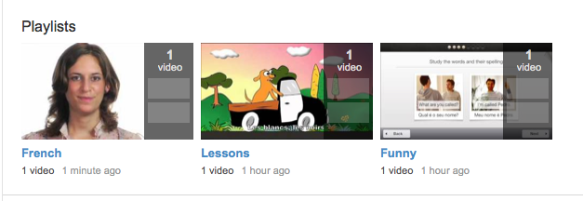

(However, the public will not be able to see your playlists until you add at least one video to them.)

6. How to add other peoples’ videos to your channel (in your playlists)

- Once you have your own YouTube channel set up, it is very easy to add videos to your playlists. To get started, you can go to my YouTube channel to find videos
http://www.youtube.com/user/sduckworth100 or you can simply start to search for videos by doing a search on YouTube:

- When you find a video you like, click on “Add to” underneath the video and add it to your playlists by clicking on the appropriate playlist:
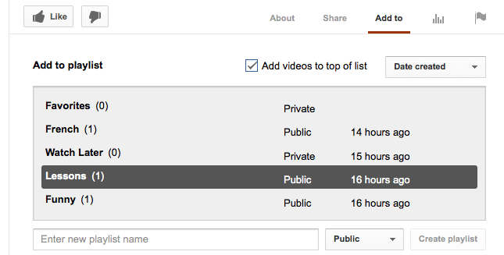
- Make sure that you check off “Add videos to top of list”.
- If you want to create a new playlist, here is another way to do it (type in name of new playlist, then “Create playlist”)
- Notice that there are two other playlists that have been created automatically for you: “Favorites” and “Watch Later”.

7. How to upload your own videos
- Click on “Upload” button on the top
- Click on “Select files to upload” and browse for the file.
- While it is uploading, you can change the privacy settings:
- The default setting is public, but you can change the video to private by clicking on dropdown list under the “Privacy settings” button:
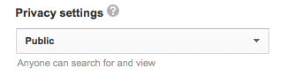
(Click here or http://goo.gl/tF72E to read about the difference between private and unlisted videos. )

- While the video is uploading, I would recommend that you change the comments settings. Click on “Video manager” on top right hand corner:
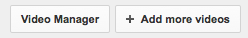

- while it is processing, put a checkmark in the box to the left of it:

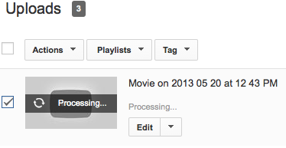
- Now scroll down to “Advanced”:
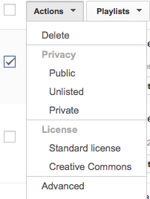
- Then click on “Comments”:
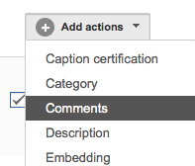

- Then click on “Allow only approved comments”
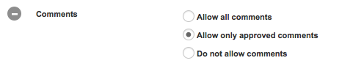
You will get an email when a comment is made and then you choose to publish it or not.

